This is a document for the client providing information on the Lifting air-bag to students in 48670 Mechanical and Mechatronic Design.

|  |  |
| --- | --- |
| **Project Name:** | Portable lifting air-bag |
| **Client:** | Malcom Turnbull / Liyang Liu |
| **Project brief:** | This is a continuation of the “Portable Lifting Device” project from 2017. The basic idea is for a portable airbag that would assist lift a person with no use of their legs from the ground to a height level with their wheelchair or another surface. It would also allow for lowering of the person from their wheelchair height to the ground or another surface (eg. A kayak). The autumn-semester team has fully explored the mechanical lifting mechanism and delivered a design for a sissor-lift device. The spring-semester project needs to focus on the pneumatic concept using electrical power.  The requirements are:   * Able to lift to a max height of 500mm. * Lowest min height possible. * Able to stop at variable heights to accommodate transfers to different height surfaces (eg. For transfer into a kayak). * Rust resistant (will be used near salt water at times) * Portable * No need for plugging into a power source when using (if power is required a rechargeable battery would be needed). * Ability for the individual to be able to use it without assistance. * No sharp edges or nuts/bolts that could cause accidental injury * The air-bag will be inflated whilst the patient is seated using an Electric Pump that will be actuated by the patient using a switche.   The mechanism for lifting/lowering should be pneumatic with battery power.  The person using the device has a spinal injury at thoracic 5 level. This means no trunk muscles so limited balance. There may be advantages in having some sort of grip handle on either side that can be taken out of the way depending on which side the transfer is coming from.  The 500mm max height corresponds to the height of the wheelchair. The height of the kayak is not known exactly but estimated to be around 350 mm.  Example rescue air-bag in market:  <https://www.vetter.de/vetter_emergency/en/Rescue+Products/Lifting+bags.html>  http://www.paratech.com/product-category/rescue-air-cushions-0  For stability reasons during inflation and deflation, the air-bag may need to consist of several layers ( similar to Russian doll layout ) to allow height variation undergo controlled stages.  Progress of last year:   * 2017 Autumn term:   + Investigated different concepts: pneumatic, hydrolic, mechanical   + Fully researched the mechanical concept and delivered CAD drawing for a sissor-lift device.   + Provided proof of concept demo for pneumatic concept with an inflatable mattress.   + Video clip attached, also viewable on URL:   <https://drive.google.com/file/d/0B8edSPbUCKdPTHlibjlWQjhMN2M>   * 2017 Spring term:   + Produced a prototype infaltable airbag   + <https://youtu.be/5JIshlNcmgY> |
| **Expected deliverables:** | What will you expect to be delivered at the end of the project?   * A prototype device |
| **Skill sets required:** | * Solidworks * FEA * Arduino * Battery as power supply |
| **# projects to be run** | We prefer to have multiple teams work on the same project to aid in assessment and facilitate peer-to-peer learning.   * FEA * Electronics |

## **Use cases for the lifting air-bag:**

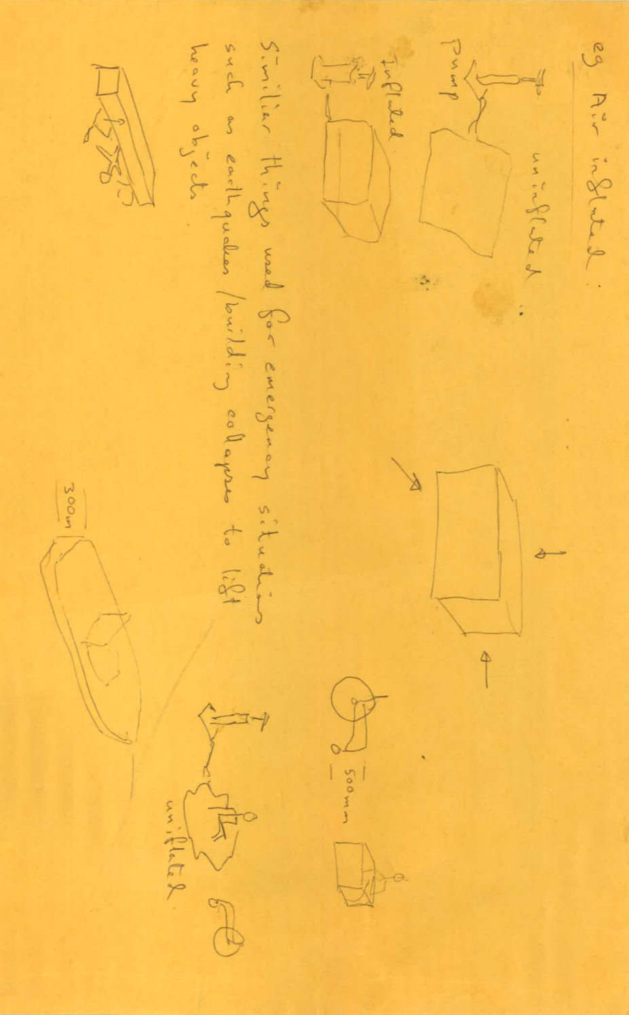

## **Client wheel chair**

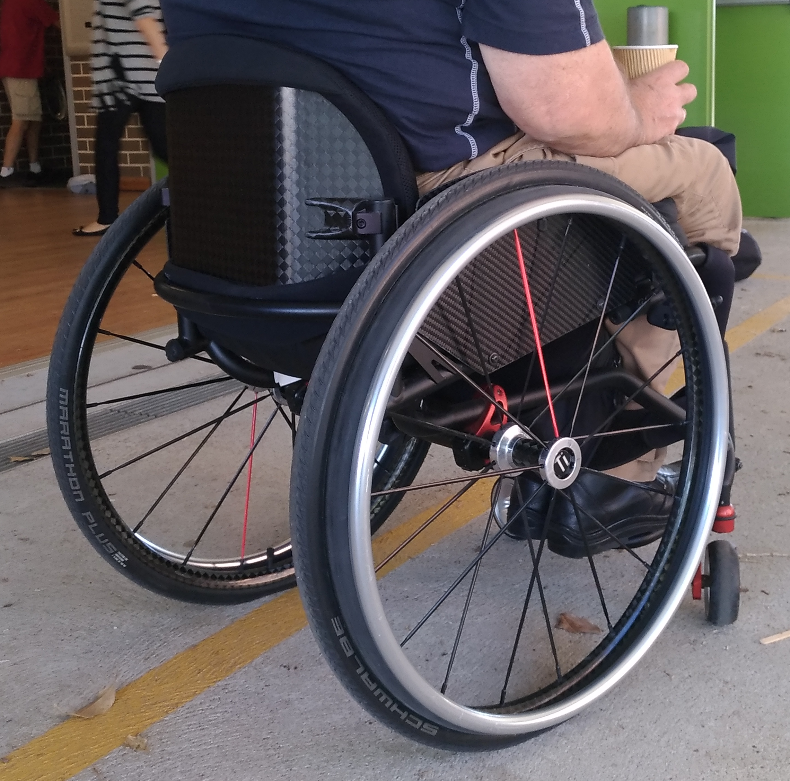

## **Attaching airbag to wheel chair – possible mechanism**

Client wheel chair can be motorised with ability to tow heavy goods along, as a second priority, the student may design a container for attachment to the motor, see url below for demo.

[http://www.max-mobility.com/smartdrive/#mx2pluspushtracker](http://www.max-mobility.com/smartdrive/" \l "mx2pluspushtracker)

http://www.max-mobility.com/device-information/#instructional-videos

**Proof of concept demo, by last team:**

## 